Gabriela Canjura & Mallory Milstead

Geographic Location Attribute Predictor System

Milestone 3

For this milestone, we made some changes to our database. We created a list with all the counties and states in the census. From this list, we selected 100 randomly and obtained the same attributes as before. Once we obtained our list, we worked on trying to use Keras and TensorFlow to create a program that would predict one attribute (medianHomeVal from the detailed table.)

Mallory worked on creating a program that would predict the attribute with Keras while Gabriela worked on a tutorial with TensorFlow and an attempt to predict this value with TensorFlow. Upon comparing both attempts, we decided to work with Keras from now going forward, and Gabriela created an attempt using Keras. Both of these attempts currently use pandas to obtain the information from the database, as well as, categorize into training test, data and targets. Then they both use linear regression to obtain the prediction.

We managed to get two models created and to predict a value; however, the value seems very inaccurate. The inaccuracy may be due to the training data being too small or an error in the creation of our models. We do know that we need to add the state codes to the data set so that the machine can learn which counties are in the same state, and how to group data for the same locations across various years.

We will work on creating a model that provides a better prediction with these attributes and then add more attributes to improve the prediction further. To complete this task, we hope to shift more toward deep and wide learning. This form of learning will hopefully apply other factors to calculations such as gradient descent that should provide a more accurate result.

Finally, to provide a more visual representation of our data we hope to use TensorBoard and Facets. This will help depict what is going on in the program.

Link to our Backend Board of Features:

<https://dev.azure.com/GLAPS-Capstone/GLAPS/_boards/board/t/Backend/Features>

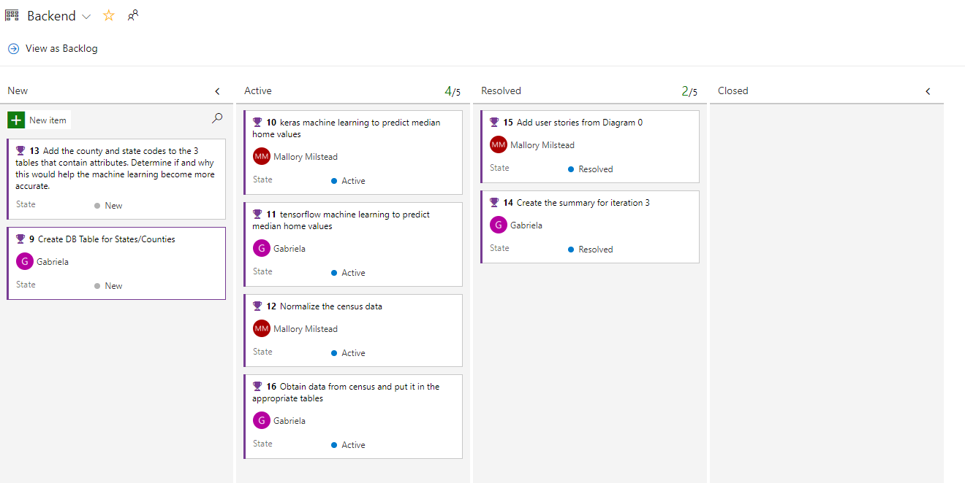

Link to the User Stories for Diagram 0:

<https://dev.azure.com/GLAPS-Capstone/GLAPS/_boards/board/t/GLAPS%20Team/Stories>

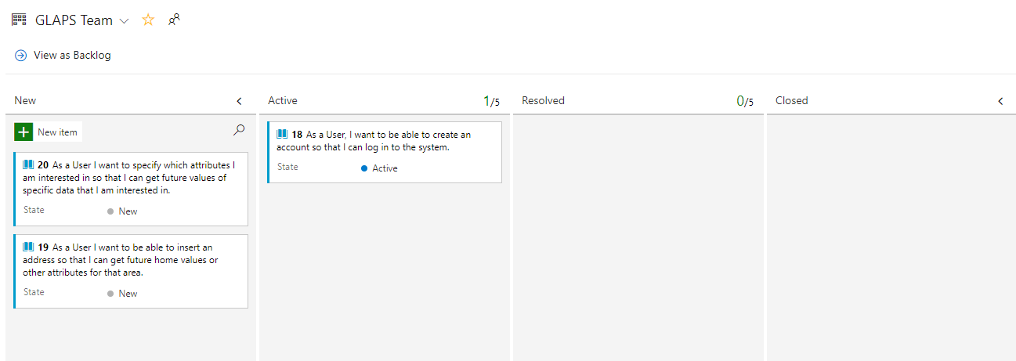

Link to Github:

https://github.com/milsteam4144/GLAPS

The master branch is the most up to date.